Lecture #3
Coulomb’s Law
" The magnitude of the electric force that a particle exerts on another particle is directly proportional to the product of their charges and inversely proportional to the square of the distance between them. The direction of the force is along the line joining the particles. "
particle | charge (C)
electron | - 1.6 x 10⁻¹⁹
proton | 1.6 x 10⁻¹⁹
neutron | 0
Table 2. Electric charges of the building blocks of atoms
The electric force F_{c} can be written as
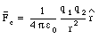
(1)
where
q₁ and q₂ are the charges of particle 1 and particle 2, respectively
r is the distance between particle 1 and particle 2 (see Figure 1)
[epsilon]₀ is he permittivity constant: [epsilon]₀ = 8.85 x 10⁻¹² C²/(N . m²)
This formula applies to elementary particles and small charged objects as long as their sizes are much less than the distance between them.
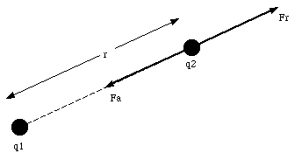
Figure 1. Electric force between two charged objects.
An important difference between the electric force and the gravitational force is that the gravitational force is always attractive, while the electric force can be repulsive (F_{c} > 0), zero, or attractive (F_{c} < 0), depending on the charges of the particles. Table 3 lists the gravitational and the Coulomb force between electrons, protons and neutrons when they are separated by 1 x 10⁻¹⁰ m. This table shows clearly that the electric force dominates the motion of electrons in atoms. However, on a macroscopic scale, the gravitational force dominates. Since most macroscopic objects are neutral, they have an equal number of protons and electrons. The attractive force between the electrons in one body and the protons in the other body is exactly canceled by the repulsive force between the electrons in the two bodies.
Our discussion of the electric force will initially concentrate on those cases in which the charges are at rest or are moving very slowly. The electric force exerted under these circumstances is called the electrostatic force. If the charges are moving with a uniform velocity, they will experience both the electrostatic force and a magnetic force. The combined electrostatic and magnetic force is called the electromagnetic forc
Coloumb’s Law for Point Charges.

